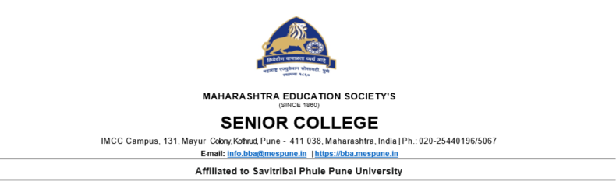

**Synopsis**

**Project Title: Anime Store**

**Submitted by: Akshad Mahajan, Ashmit Singh 2230047, 2230083**

**Objective:**

**Facilitate online sales of anime merchandise, including DVDs, Blu-rays, manga, collectibles, apparel, and other related products. Provide features that allow users to discover new anime series, movies, and merchandise through recommendations, featured products. Ensure the website is optimized for various devices and screen sizes, providing a seamless user experience across desktops, tablets, and mobile devices. Implement robust security measures to ensure the safety of customer data and facilitate secure transactions for online purchases.**

**Introduction:**

**Welcome to Anime Store, your ultimate destination for all things anime! Immerse yourself in a world of captivating stories, vibrant characters, and exclusive merchandise curated just for you. At Anime Store, we are passionate about bringing the magic of anime to fans worldwide, offering a one-stop-shop for all your anime cravings.**

**Discover a Universe of Possibilities: Step into a realm where imagination knows no bounds. Whether you're a seasoned otaku or just starting your anime journey, our store is a treasure trove of handpicked anime merchandise, ranging from the latest releases to timeless classics. From awe-inspiring figurines to collector's edition Blu-rays, we've got it all.**



**Shop with Confidence: At Anime Store, your satisfaction and security are our top priorities. Our user-friendly interface and secure payment gateways make shopping a breeze. Rest easy knowing that your personal information is handled with the utmost care, ensuring a safe and enjoyable shopping experience.**

**Exclusive Deals and Promotions: Indulge in your passion without breaking the bank! Take advantage of our exclusive deals, promotions, and discounts that make collecting anime merchandise even more rewarding. Be on the lookout for limited-time offers and special bundles that add extra value to your purchases.**

**Join Our Community: Become part of a vibrant community of anime enthusiasts. Connect with like-minded fans through our forums, social media channels, and events. Share your thoughts, recommendations, and excitement for all things anime. At Anime Store, we celebrate the sense of camaraderie that anime fosters among its fans.**

**Stay Updated and Inspired: Keep your finger on the pulse of the anime world with our regularly updated blog, featuring reviews, news, and insider insights. Get inspired by the latest trends, fan theories, and behind-the-scenes glimpses into the creation of your favorite anime series.**

**Embark on a journey with Anime Store and let the magic of anime come to life. We are more than just a store; we are a celebration of the art, culture, and community that make anime a truly unique and cherished experience. Start your adventure today!**

**Technology Used:**

1. **HTML**
2. **CSS**
3. **JavaScript**



**Modules:**

**1. Login Module:**

**- User Registration: Allow users to create accounts by providing necessary information.**

**- Login/Logout: Provide a secure login system with options for users to log in and log out.**

**- User Profiles: Enable users to manage their profiles, update personal information, and track order history.**

**- Password Recovery: Implement a secure process for users to recover their passwords if forgotten.**

**2. Contact Us Module:**

**- Contact Form: Include a user-friendly contact form for general inquiries and support.**

**- Customer Support Information: Display contact details, including email addresses and phone numbers, for customer support.**

**- Physical Address: Provide the physical location of the store (if applicable) for customers who prefer in-person assistance.**

**3. Feedback Module:**

**- Customer Reviews: Allow users to leave reviews and ratings for products they have purchased.**

**- Feedback Form: Implement a feedback form for users to share their thoughts, suggestions, and concerns.**

**- Moderation: Admin tools for moderating and responding to user feedback to maintain a positive community.**



**4. Products Module:**

**- Product Listings: Display a comprehensive catalog of anime products, organized by categories and genres.**

**- Product Details: Include detailed information about each product, including images, descriptions, specifications, and prices.**

**- Search and Filter: Implement search functionality and filters to help users easily find specific products.**

**- Inventory Management :Admin tools for managing product availability, restocking, and updating product information.**